PUNE DISTRICT EDUCATION ASSOCIATION’S
SETH GOVIND RAGHUNATH SABLE COLLEGE OF PHARMACY
SASWAD, DIST-PUNE

Activity Report
Title of the event: International Women’s Day
Name of activity: Guest Lecture on Women Empowerment
Date and Day: Saturday, 09th March 2024 Time: 11.30am to 12.45pm
Venue: Seminar Hall
No. of participants: 1. Students: 64
2. Staff: 23

The institute organized a guest lecture on “International Women’s Day” on 09th March 2024 at 11.30am. under the guidance of Principal Dr. R. S. Chavan. Dr.Pandit Shelke, (Principal, Waghire College, Saswad) chief guest of the program delivered the guest lecture on topic “Women Empowerment”. He focused on the declining Child Sex Ratio (CSR) and related issues of women empowerment over a life-cycle continuum. He also encouraged us for women's empowerment in order to improve women status in the country. Principal Dr.R.S.Chavan also guided about of girl’s education and its importance. On this occasion all ladies staff member was felicitated by giving rose and shreephal. About 64 students and 23 staff members attended the program.
The preamble of this function was delivered by Ms. Shivani Garud (Student S.Y.B.Pharm). Principal Dr. R.S. Chavan addressed the students and staff. The program came to an end by vote of thanks by Ms.Rutuja Jagtap (Student S.Y.D.Pharm). The program was coordinated by Ms. Sayali Chavan and Mrs. Sunita Bathe.

Mrs.S.B.Bathe Ms.S.S.Chavan Mrs.V.S.Gaikwad Dr. R. S. Chavan
Coordinator Coordinator Coordinator Principal

Photo Gallery (09/03/2024)
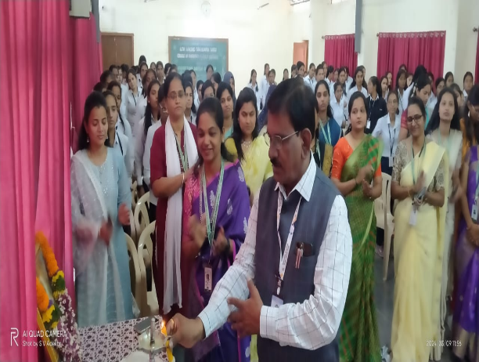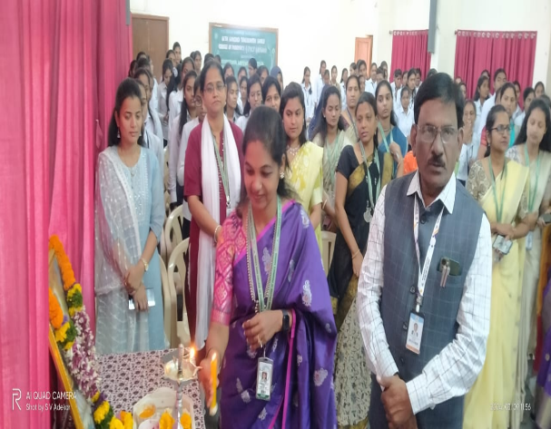
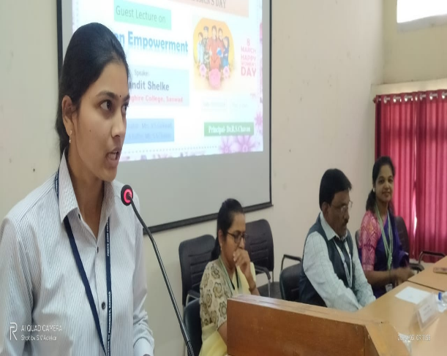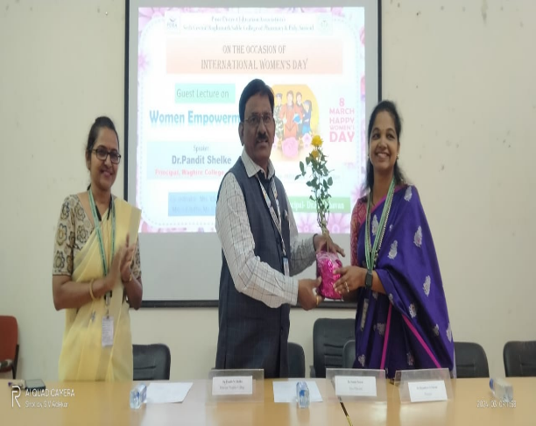
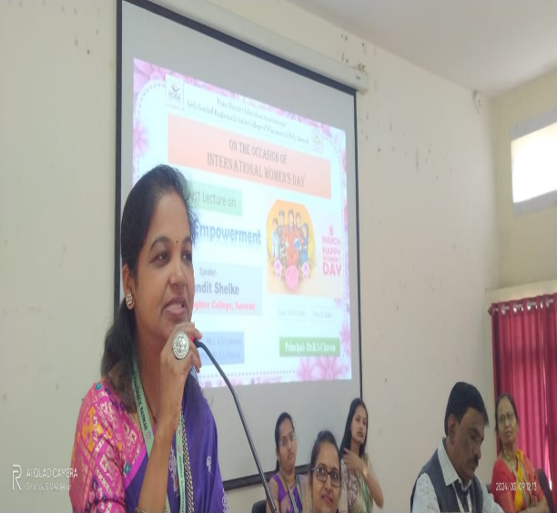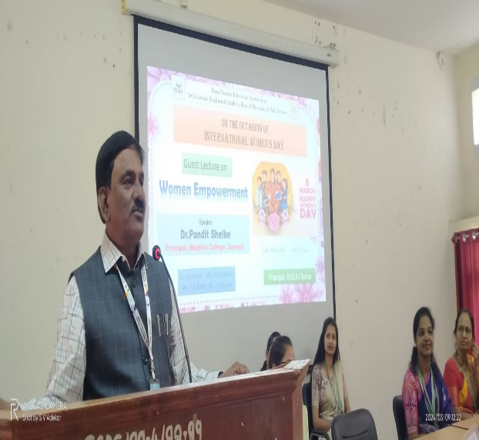

Dr.R.S.Chavan

